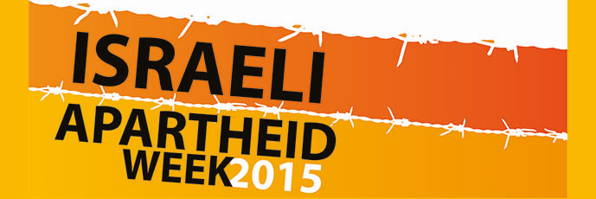

http://apartheidweek.org

Israeli Apartheid Week (IAW) is an international series of events that seeks to raise awareness of Israel’s apartheid system over the Palestinian people and to build support for the growing boycott, divestment and sanctions (BDS) movement.

In 2014, IAW events including rallies, lectures, cultural performances, film screenings, multimedia displays and BDS actions were held across more than 200 cities and university campuses in 28 countries.

Unprecedented numbers of people took to the streets to protest Israel’s recent massacre of more than 2,300 Palestinians in Gaza, yet most governments and many corporations continue to provide Israel with support for its crimes. IAW is a chance to speak out about Israel’s most recent war crimes and all its violations of international law, as well as a way of campaigning to end international support for them.

Ten years on from the launch of the BDS campaign, this year’s Israeli Apartheid Week is also an opportunity to reflect on the success of the movement so far⁽¹⁾, and build for the continued growth and impact of our BDS campaigns.

(1) http://www.bdsmovement.net/2014/round-up-13017

History of Israeli Apartheid Week
Israeli Apartheid Week (IAW) is an international series of events held in cities and campuses across the globe. IAW will be running for the tenth consecutive year in 2014, with events taking place in March all over the world. The week’s events will include lectures, multimedia events, cultural performance, film screenings, demonstrations, and more.
The past few years have seen a sharp increase of literature and analysis that has sought to document and challenge Israeli apartheid, including reports issued by major international bodies and human rights organizations and findings published by political leaders, thinkers, academics, and activists. Many of these efforts have highlighted the role that could be played by people and governments across the world in providing solidarity with the Palestinian struggle by exerting urgent pressure on Israel to alter its current structure and practices as an apartheid state. Prominent Palestinians, Jewish anti-Zionists, and South Africans have been at the forefront of this struggle.
At the same time, an international divestment campaign has gained momentum in response to a statement issued in July 2005 by over 170 Palestinian civil society organizations calling for boycotts, divestments and sanctions (BDS) against apartheid Israel. Important gains have recently been made in this campaign in countries like South Africa, the United Kingdom , Canada and the United States .
The aim of IAW is to contribute to this chorus of international opposition to Israeli apartheid and to bolster support for the BDS campaign in accordance with the demands outlined in the July 2005 Statement: full equality for Arab-Palestinian citizens of Israel, an end to the occupation and colonization of all Arab lands – including the Golan Heights, the Occupied West Bank with East Jerusalem and the Gaza Strip – and dismantling the Wall, and the protection of Palestinian refugees’ right to return to their homes and properties as stipulated in U.N. resolution 194. In previous years IAW has played an important role in raising awareness and disseminating information about Zionism, the Palestinian liberation struggle and its similarities with the indigenous sovereignty struggle in North America and the South African anti-apartheid movement. Join us in making this a year of struggle against apartheid and for justice, equality, and peace.

